Modify the About action in the HomeController, in order to pass a viewbag containing your location (as a string) into the About view.

Using an AboutModel class, transfer the Name and Location strings to the About view.

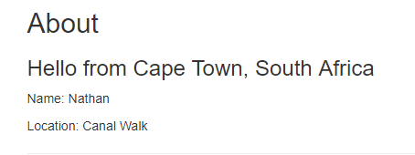

Add a page to the website which allows for the user to search for a specific cuisine. At the moment, clicking the search button should not do anything.

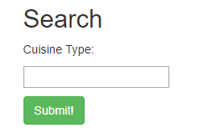

Tie the search to a model, so that a search for the Finnish cuisine type takes you to a page which says that your search was for Finnish cuisine.

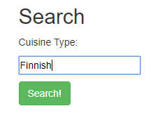

Create a restaurant class. A restaurant should have a Name, City and Country. The restaurant will also have a bunch of reviews associated with it.

Create a DbContext file for Entity framework to persist and query the database.

Make the homepage display all the restaurants which are in the database. At the moment, this will be blank because the database is empty.